Knowledge discovery and Management

CS560

Report on LAB-4 tutorial

By : Vidhi Shah

16178723

Complete the following tasks:

1. Cloudera / Mahout / Solr: Implement a Mahout application (e.g., classification/Recommedation/Association Rule Mining) using your own data and store your output to Solr.

Answer:

1. **Implementing Association With Mahout Frequent Pattern Mining:**

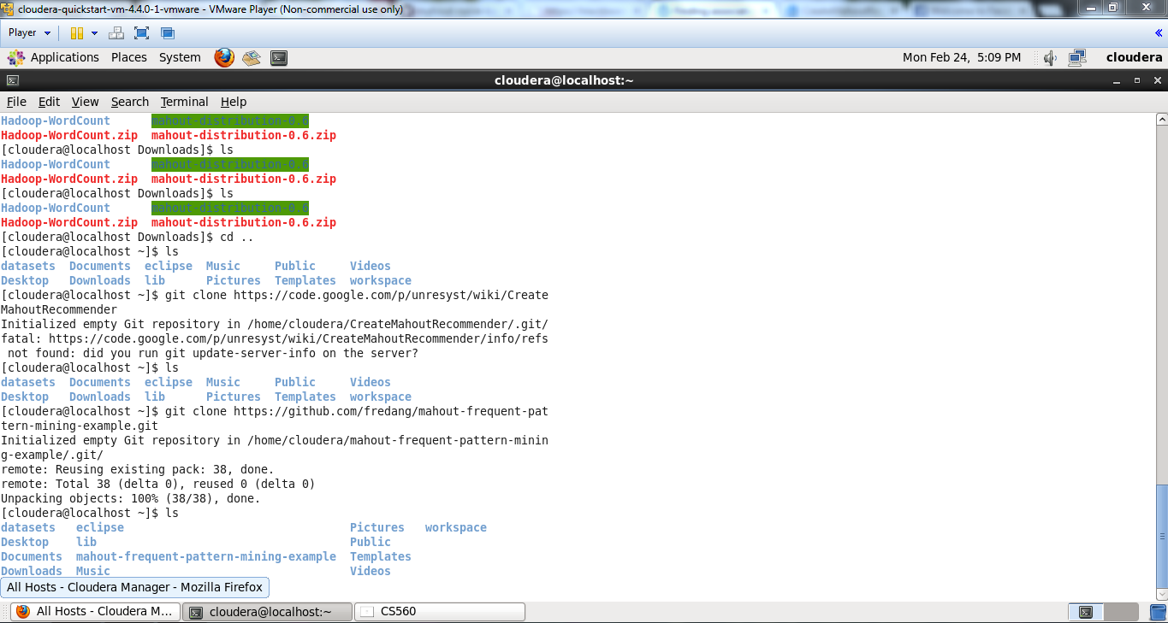

The screen shot shows the data in the mapping file.

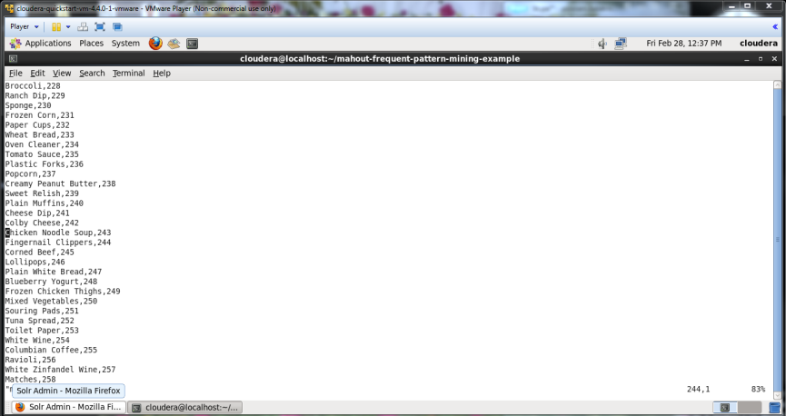

The below screen shows sending output file to the Hadoop file system.

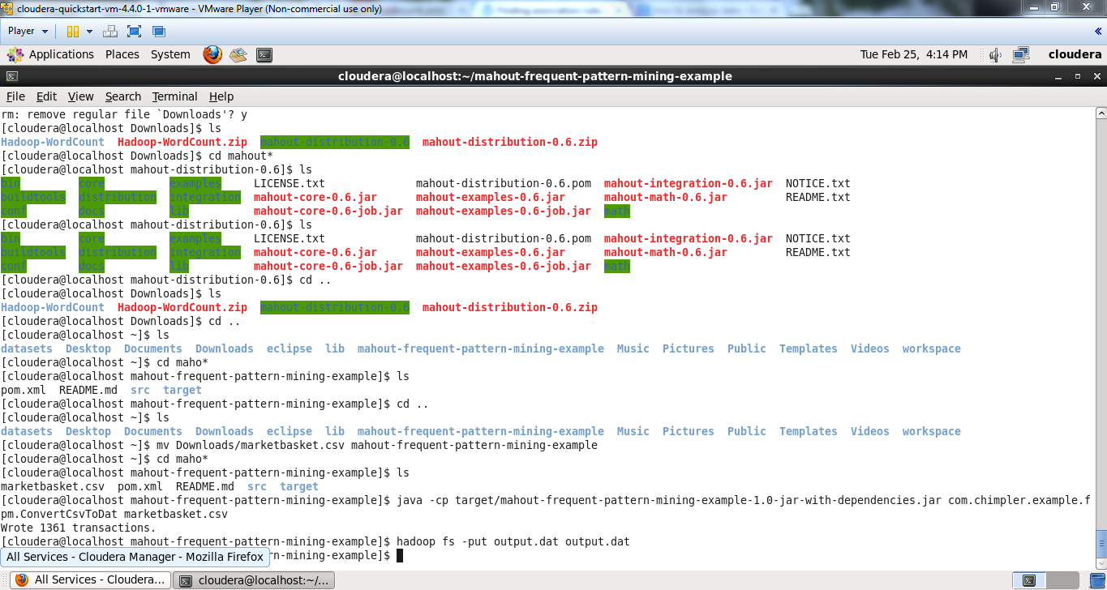

The below screen shows the output in the text file.

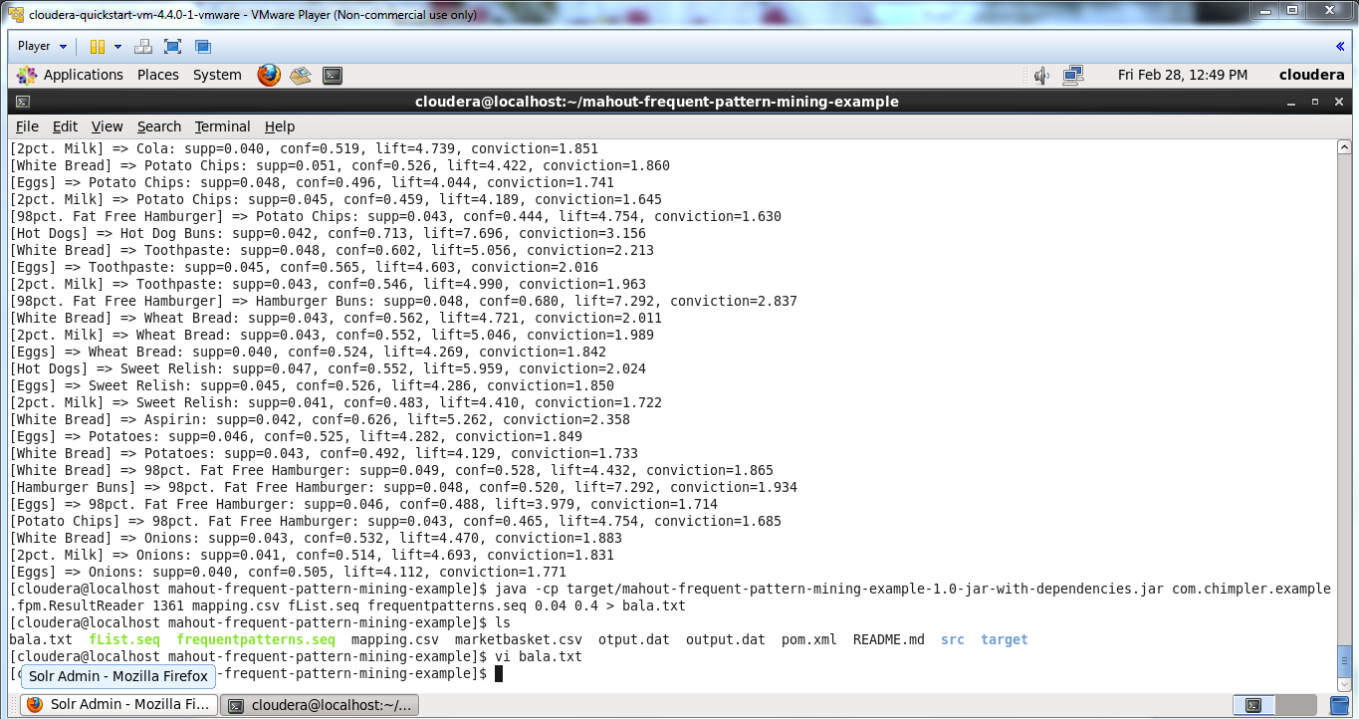

The below screen shows the all data which is inserted by querying

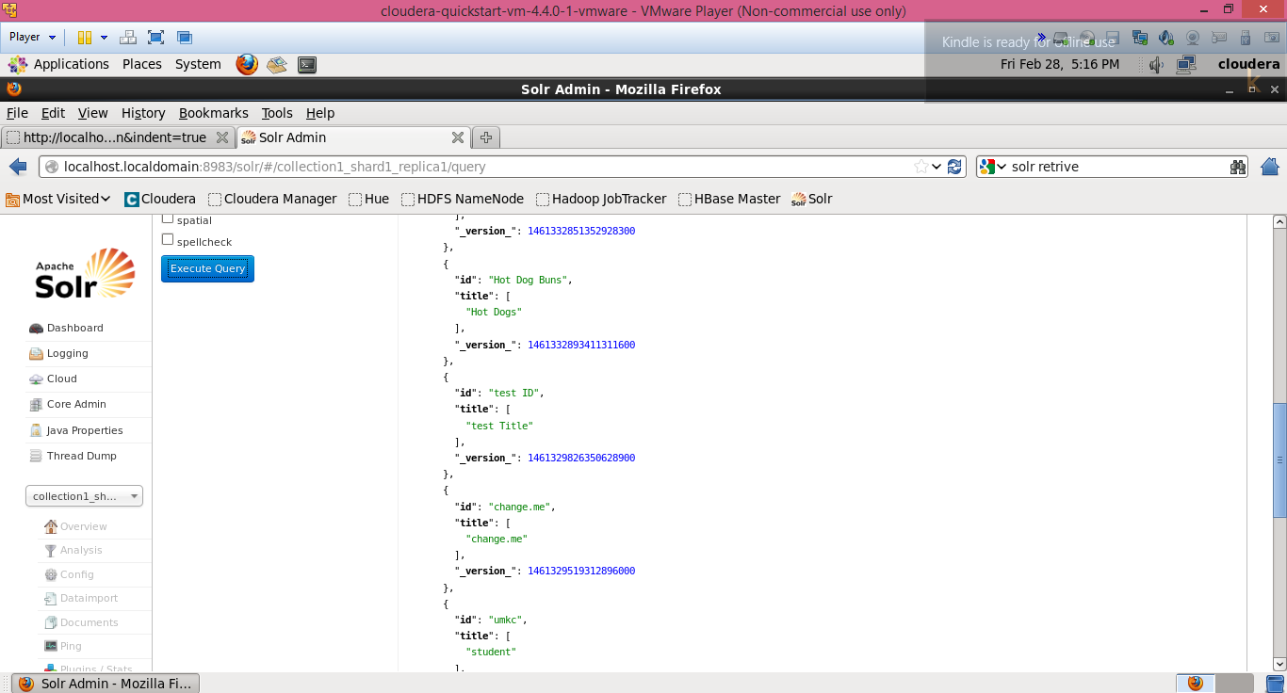

The below screen shows the uri and data of all items.

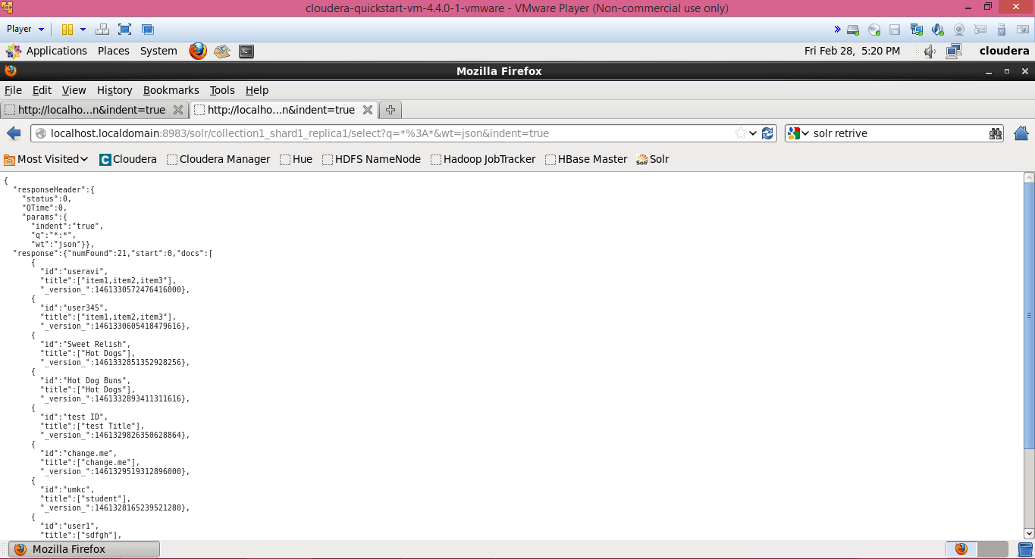

1. **Mobile Client Application :**

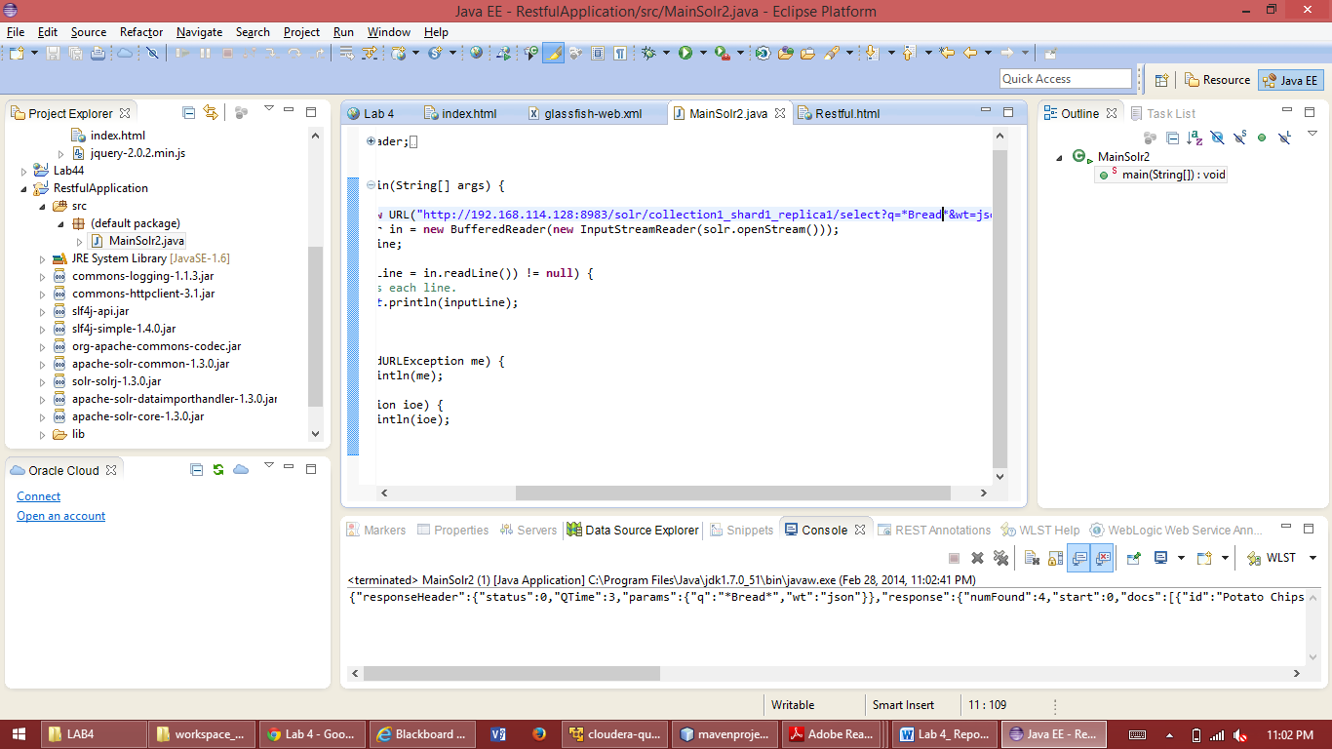

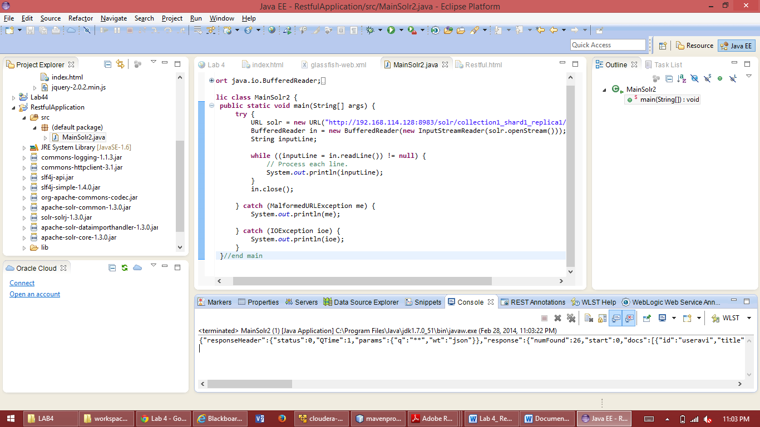

The below screen shows the Getting Association through URL from app

